Introduction to Artificial intelligence
Tutorial Sheet 5 (Adversarial Search and CSPs)
Exercise 1:
This problem exercises the basic concepts of game playing, using tic-tac-toe (noughts and crosses) as an example. We define Xn as the number of rows, columns, or diagonals with exactly n X’s and no O’s. Similarly, On is the number of rows, columns, or diagonals with just n O’s. The utility function assigns +1 to any position with X3 = 1 and -1 to any position with O3 = 1. All other terminal positions have utility 0. For nonterminal positions, we use a linear evaluation function defined as Eval(s) = 3X2(s)+X1(s)-(3O2(s)+O1(s)).
a. Approximately how many possible games of tic-tac-toe are there?
b. Show the whole game tree starting from an empty board down to depth 2 (i.e., one X and one O on the board), taking symmetry into account.
c. Mark on your tree the evaluations of all the positions at depth 2.
d. Using the minimax algorithm, mark on your tree the backed-up values for the positions at depths 1 and 0, and use those values to choose the best starting move.
e. Circle the nodes at depth 2 that would not be evaluated if alpha–beta pruning were applied, assuming the nodes are generated in the optimal order for alpha–beta pruning.

Exercise 2:
This question considers pruning in games with chance nodes. Figure below shows the complete game tree for a trivial game. Assume that the leaf nodes are to be evaluated in left-to right order, and that before a leaf node is evaluated, we know nothing about its value—the range of possible values is -∞ to +∞.
a. Copy the figure, mark the value of all the internal nodes, and indicate the best move at the root with an arrow.
b. Given the values of the first six leaves, do we need to evaluate the seventh and eighth leaves? Given the values of the first seven leaves, do we need to evaluate the eighth leaf? Explain your answers.
c. Suppose the leaf node values are known to lie between –2 and 2 inclusive. After the first two leaves are evaluated, what is the value range for the left-hand chance node?
d. Circle all the leaves that need not be evaluated under the assumption in (c).
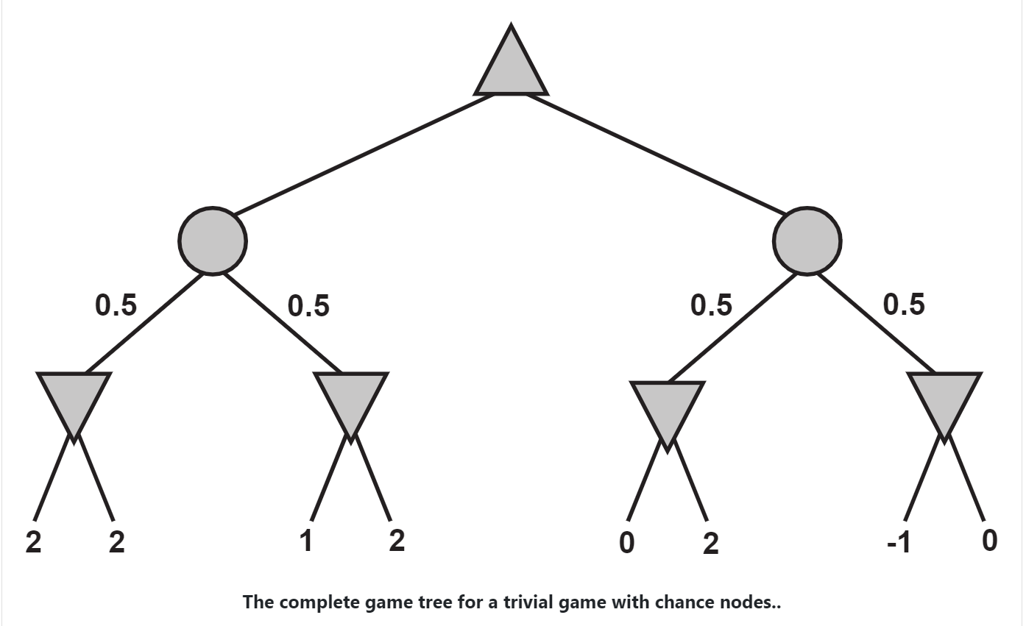

Exercise 3:
Mom, Dad, Baby, Student, Teacher, and Guide are lining up next to each other in six linear spots labeled 1 to 6, one to a spots. Baby needs to line up between Mom and Dad. Student and Teacher need to be next to each other. Guide needs to be at one end, in spot 1 or 6.
- Formulate this problem as a CSP: list the variables, their domains, and the constraints. Encode unary constraints as a constraint rather than pruning the domain. (No need to solve the problem, just provide variables, domains and constraints.)

Exercise 4:
Consider the problem of placing k knights on an n × n chessboard such that no two knights are attacking each other, where k is given and k ≤ n2.
a. Choose a CSP formulation. In your formulation, what are the variables?
b. What are the possible values of each variable?
c. What sets of variables are constrained, and how?
d. Now consider the problem of putting as many knights as possible on the board without any attacks. Explain how to solve this with local search by defining appropriate ACTIONS and RESULT functions and a sensible objective function.

